**Stag - Wooden Animal Wall Mount**

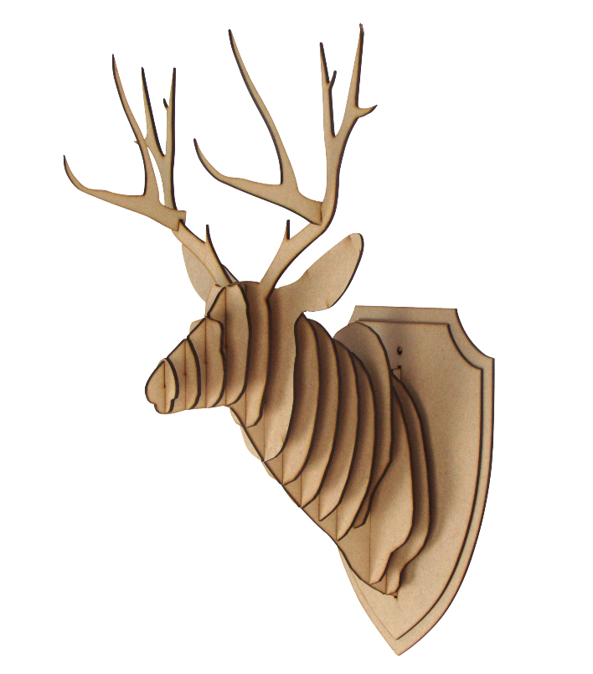The Stag Wooden Animal Wall Mount is a striking and rustic decor piece that combines the natural beauty of wood with the majestic presence of a stag. Crafted from high-quality wood, this mount features the intricately carved head and antlers of a stag, creating a sophisticated yet earthy aesthetic. The rich texture and warm tones of the wood bring an organic, handcrafted feel to any room, while the minimalist design maintains a contemporary appeal. Ideal for nature lovers and those seeking a rustic or woodland-inspired touch, this wall mount adds depth, elegance, and a sense of the wild to any interior.